Higher education students of all ages are invited to share their perspectives and research on topics associated with global understanding by creating Story Maps that examine and address the ways in which we inhabit our increasingly globalized world.

Benno Werlen, University of Jena – IYGU
Karl Donert – EUROGEO
Kathrin Viehrig – CGE
Dawn Wright – ESRI

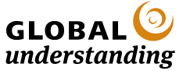

CONTACT

Competition information http://go.esri.com/IYGU-Competition

International Year of Global Understanding http://www.global-understanding.info/

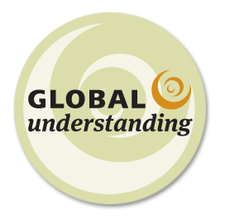

Higher education students,
Tell Your Story!
International Year of
Global Understanding
Story Map Competition
Use an Esri Story Map to share your story!

Together with EUROGEO, ESRI, and the International Geographic Union Commission for Geographic Education, the International Year of Global Understanding (IYGU) has launched a Story Map Competition. It is a contest aimed at young people from around the world to help raise awareness of the global implications of local everyday actions. Our world faces social, cultural, and economic change, as well as a changing climate. Human actions play a key role in creating such worldwide challenges. However, human actions also provide solutions. If individuals know what their day-to-day routines mean for the planet, they can take appropriate action. Global understanding helps overcome the knowledge-action gap and supports policy decisions that promote sustainability.

Who can enter
Higher education students between the ages of 19 to 30 are encouraged to participate. Working solely on your own, your Story Map will be based on research you have done. Using the ESRI Story Map site, you should create a concise story map that connects the local action with its global implications.

How to do it
It should be based on maps, with additional multimedia (pictures, visualizations, data,
video) and text in which you present your research and studies, or focus on future perspectives of your theme. Use your own primary and secondary data sources to connect the local action with its global implications. The story map should not only describe phenomena (what, where) but also explain them (how, why, effects).

Themes
Your story map should focus on one (or more) of the 6 official IYGU themes:
- Eating, drinking: surviving
- Moving, staying: belonging
- Working, housing: urbanizing
- Communicating: networking, interacting
- Wasting, recycling: preserving
- Sports, entertaining: recreating

Prizes
Enter for the chance to win one of three prizes!
- First place 1500€ and an IYGU book
- Second place 500€ and an IYGU book
- Third place 250€ and an ICU book
Get Started
To get started go to the competition website

http://go.esri.com/IYGU-Competition

- Register for the competition and receive an email with further instructions
- Get started with your own ArcGIS Online Account or get a free, non-commercial account

Key dates
- Sept 26, 2016 - Competition Open
- Dec 31, 2016 - Competition closes at 5:00 p.m. PST
- March 15, 2017 - Winners announced

For more information
Visit the competition website to see the official rules and terms and conditions, as well as answers to frequently asked questions

